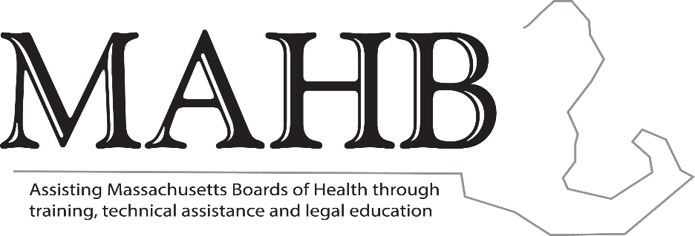

MASSACHUSETTS ASSOCIATION OF HEALTH BOARDS

Executive Board Meeting
6.2.22

Agenda

- AAFCPA’s Report – Amy Staunton, CPA
  - Proposed consolidated budget
- Certificate Programs update – Cheryl Sbarra, JD
  - Webinar
- Future trainings – Cheryl Sbarra, JD
  - State Ethics Commission
  - Monthly webinars
- SAPHE 2.0 update – Mike Hugo, JD
- Legislative Update – Mike Hugo, JD
- Grants update
  - MTCP (MAHB 01) – Cheryl Sbarra, JD
  - Legal TA (MAHB 07) – Cheryl Sbarra, JD
  - Mini Grant (MAHB-02) – Cheryl Sbarra, JD
  - HMCC – Elaine LaCoursiere

